Ui testing

Layouts spacing overlapping missing content oss alinment

Fornt diff type size family

Color colour ismath button

Content lower mismatch letters images spelling mistakes

Finding reporting testcases

Functional testing blackboxtesting don’t know how its work

Compatability testing

Hardware operrsting software network browser divises mobile

Localization testing lang currency date a ndtime

Performance testing scalabilityspeed

Uabilitytesting wrong button pressing control free

Securitytesting

Monkey testing ad-hoctesting randomely

backlog

Type Summary descriptive screenshot

Bud missing more clear explanaton photo

Bug triage priorize minor bugs

Severity priority

Priority classes –low less important high mediumcant wait new verson is created

Severity

Critica; non critical

Urgent key feature don’t work company logo in wrong color

priority

low feature that is rarely used do not work the caption on image in wrong fornt

test cases

set of actiions to verify perticuar feature

it clearifies what to done

excel

process testcases steps description status expected results actual resuts

writing

executing

comment if fails

jira piphyr

intervie rite test case for login

test cases

pre conditions

user on login page

steps user login with credentials

expected results

documentation should clear

smoke testing

we look for main functions

browserss account broken

hapy path

test plan

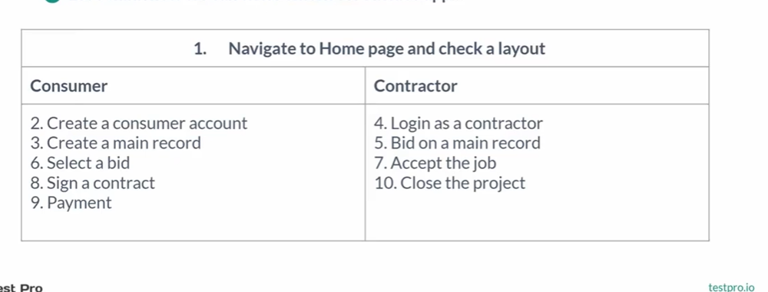

Summary preconditions steps tedt data links expected results actual results ppass fail note

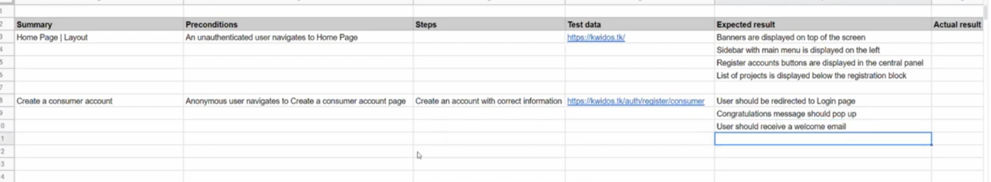

Mobile divices

Using different divices

Crome diff mobile divises

One that customer use

Browser segmentation

Crome general people corporation explore

Emulators stimulators directly disply in system

Ios xcode test fight

Android studio genymotion

Cloud services source lbe browser stack virtual devices

Cross browser testing

Test plan

Teestingscope and activity

Basis for testing any software blueprint

Regression testing changes may not effect before code everthing will be test 190.

New feature defect fixing anyother fix

Regression testing 1.retest testing all 2.regression test selection only effected part ony testing 3.prioritization test cases most imp functionalities

Selecting test cases

1Frequent defects

2Visible to user

3 Core feature of product

4Recently changed

Type of testing

Positive tsting negative tesing giving wrong data

Boundary value analysis ranges

Equivalesnt partion divide equally sample values random

Web architecture

Client and server

Back end net databases sever side testing

Front end web appli testing mobile desktop tesing

Built

Text excutable code compiler process

Deployment

Running on remote server

Releasing

Userstory

Sdlc customer request product owwneercreate story developer qa costome accept feature

Work flow

Local --- dev smoke---qa feature testingr –stage smoke auto regres manual---pprod sanity smoke

Sanity testing

Light weight testing like button color

User acceptance testing it done my customer owner